Dell Client Device Manager – Ring Deployments Explained

DCDM has it’s .admx file that is imported into Intune. It has a setting called “enable ring deployment” which may indicate it is tied into the native Intune ring deployments, but it has nothing to do with them.

Setting in Intune GPO’s


What this setting does.
When set to not configured or disabled when DCDM runs it will get the latest updates. When set to enabled it will get (N-1) updates.

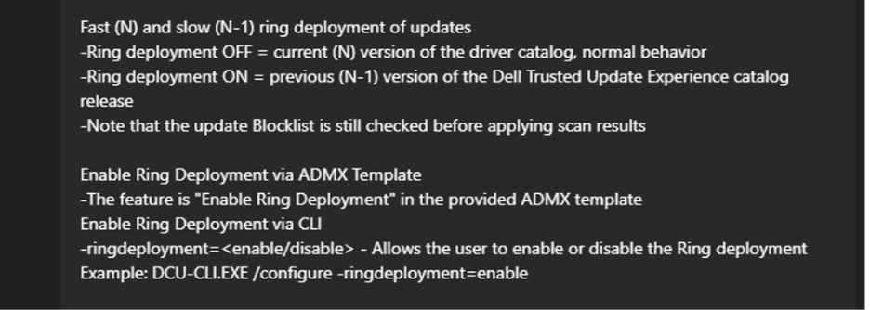
Release schedule for updates
Dell Client Drivers and Downloads Update Release Schedule | Dell US

In Production
You can create two groups. Pilot and Prod.
Pilot would get the most up to date drivers, updates. Then you can test them to make sure everything updates and works as expected.
Prod would be N-1 helping to ensure systems are stable.

